Historical Dictionary

What is Historical Dictionary
# Source: AI Source: Provided by: [Data Path: Persons Table -> ID Column: 1, Name_En Column: Motasem Essam] -> From: [Chatgpt (GPT-4-turbo)] on [7/29/2025]
A Historical Dictionary traces the origin, development, and evolution of words over time. It doesn’t just define a word’s current meaning—it documents how its form and usage have changed across historical periods. These dictionaries are invaluable for linguists, historians, etymologists, and researchers interested in the diachronic study of language.

🔹 Key Features of a Historical Dictionary
# Source: AI Source: Provided by: [Data Path: Persons Table -> ID Column: 1, Name_En Column: Motasem Essam] -> From: [Chatgpt (GPT-4-turbo)] on [7/29/2025]
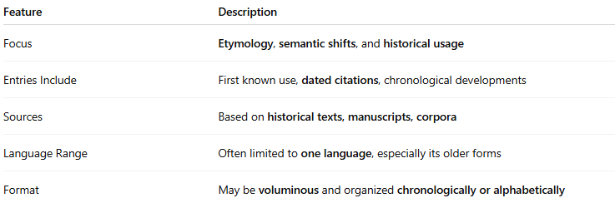
Feature | Description
Focus | Etymology, semantic shifts, and historical usage
Entries Include | First known use, dated citations, chronological developments
Sources | Based on historical texts, manuscripts, corpora
Language Range | Often limited to one language, especially its older forms
Format | May be voluminous and organized chronologically or alphabetically

🔹 Examples of Historical Dictionaries
# Source: AI Source: Provided by: [Data Path: Persons Table -> ID Column: 1, Name_En Column: Motasem Essam] -> From: [Chatgpt (GPT-4-turbo)] on [7/29/2025]
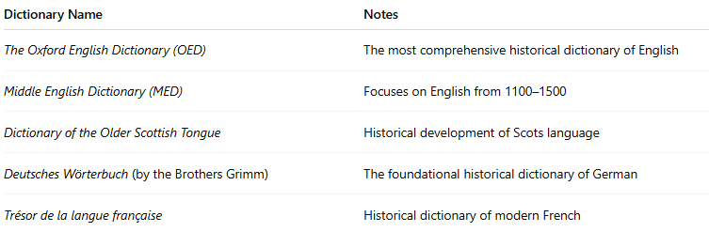
Dictionary Name | Notes
The Oxford English Dictionary (OED) | The most comprehensive historical dictionary of English
Middle English Dictionary (MED) | Focuses on English from 1100–1500
Dictionary of the Older Scottish Tongue | Historical development of Scots language
Deutsches Wörterbuch (by the Brothers Grimm) | The foundational historical dictionary of German
Trésor de la langue française | Historical dictionary of modern French

🔹 Advantages
# Source: AI Source: Provided by: [Data Path: Persons Table -> ID Column: 1, Name_En Column: Motasem Essam] -> From: [Chatgpt (GPT-4-turbo)] on [7/29/2025]
- Reveals the etymological depth of words
- Helps track language evolution and cultural change
- Essential for interpreting historical documents and literature
- Aids comparative linguistics and historical linguistics research

🔹 Use Cases
# Source: AI Source: Provided by: [Data Path: Persons Table -> ID Column: 1, Name_En Column: Motasem Essam] -> From: [Chatgpt (GPT-4-turbo)] on [7/29/2025]
- Historical linguistics and etymology research
- Literary analysis and interpretation of older texts
- Lexicography and dictionary-making
- Language documentation and preservation

